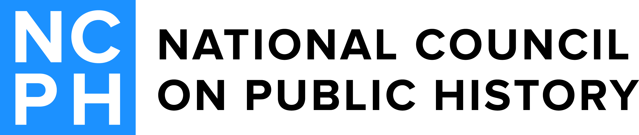
2017 G. Wesley Johnson Award Committee
Julie Davis (Chair)  2014-2017  Research for Indigenous Community Health (RICH) Center, University of Minnesota  201 N. 21st Ave E. #2  Duluth, MN 55812  historianonfire@gmail.com | Donna DeBlasio  2014-2017  Youngstown State University  Department of History  One University Plaza  Youngstown, OH 44555  dmdebalasio@ysu.edu
Sara Case  Ex officio  The Public Historian Managing Editor  UC Santa Barbara- Dept. of History  552 University Road  HSSB 4216  Santa Barbara, CA 93106  scase@history.ucsb.edu | Kelly Spradley-Kurowski  2015-2018  National Park Service  1201 I Street NW, #2261  8th Floor  Washington, DC 20005  kelly_sprakdley-kurowski@nps.gov
George Boudreau
2016-2019
LaSalle University
Department of History
1900 W. Olney Avenue
Philadelphia, PA 19119
boudreau@lasalle.edu

