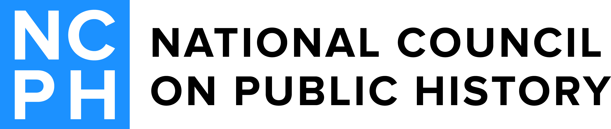
2017 Robert Kelley Award Committee
Marianne Babal(Chair)  2015-2018  Wells Fargo Bank  514 Blithedale Ave.  Mill Valley, CA 94941-2150  babalm@wellsfargo.com | Victoria Harden  2015-2018  Consulting Historian  3152 Gracefield Rd. #119  Silver Spring, MD 20904-5898  vharden@outlook.com
Patrick O’Bannon  2016-2019  Gray & Pape  60 Valley Street  Suite 103  Providence, RI 02909  pobannon@graypape.com | Anne Whisnant  2016-2019  East Carolina University  9115 Laurel Springs Drive  Chapel Hill, NC 27516-5646  amwhisnant@gmail.com

