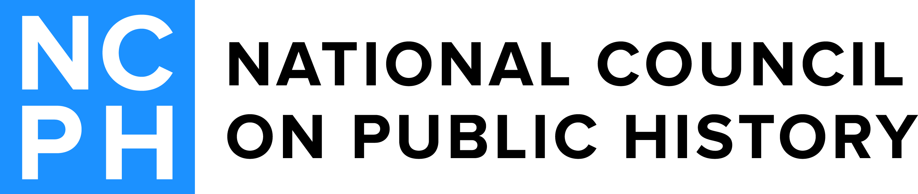
2017 Student Awards Committee
Erin McLeary (Chair)  2014-2017  Independent Historian  4918 Osage Avenue  Philadelphia, PA 19143  emcleary@chemheritage.org | Martha Tye  2014-2017  Atlanta History Center  19 Daniel Avenue NE  Atlanta, GA 30317  MTye@atlantahistorycenter.com
Ella Howard  2014-2017  Wentworth Institute of Technology  550 Huntington Ave.  Boston, MA 02215  ellahoward@gmail.com | Annie Anderson  2016-2019  Eastern State Penitentiary Historic Site  2027 Fairmount Ave.  Eastern State Penitentiary  Philadelphia, PA 19130  aa@easternstate.org
Anne Lindsay
2016-2019
California State University, Sacramento
Tahoe Hall 2087, MS 6059
6000 J Street
Sacramento, CA 95819
anne.lindsay@csus.edu

