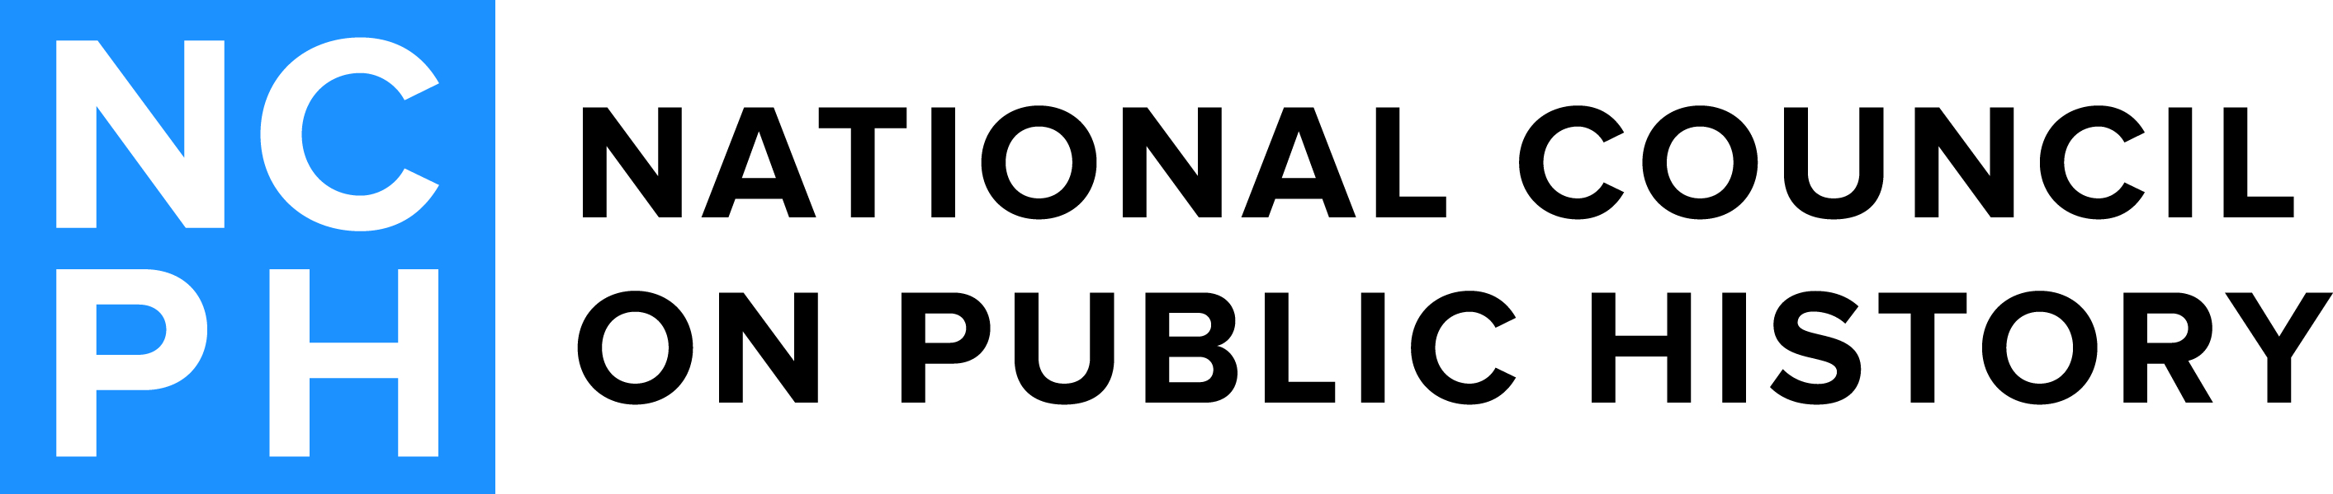
2017 Outstanding Public History Award Committee
Rebekah Dobrasko(Chair)  2014-2017  Texas Department of Transportation  1806 River Crossing Cir., Apt C  Austin, TX 78741  rdobrasko@hotmail.com | Robert Townsend  2014-2017  American Academy of Arts & Sciences  8019 Sky Blue Drive  Alexandria, VA 22315-5021  rbthisted@gmail.com
Andrea Burns  2015-2018  Appalachian State University  1824 Old US Hwy 421  Vilas, NC 28692  burnsaa@appstate.edu | Erin Bernard  2016-2019  Philadelphia History Truck  1830 S Bancroft St  Philadelphia, PA 19145  phillyhistorytruck@gmail.com

