VISITOR ENGAGEMENT & MUSEUM TECHNOLOGIES | COVID-19 ARCHIVE, DUE 4/14/20 8 AM to MyCourses (50 points)
MUSE 360 01 Dr. Juilee Decker 2195 | Spring 2020
Together we will use technology to contribute to an inclusive digital archive of the virus. Building a crowdsourced digital archive of the virus, and its impact on everyday life, offers a ready-made opportunity for all of us to engage what it means to be an academic, an historian, an archivist – to be human. Each of us is asked to gather images and information about 5 items concerning COVID-19, social distancing, closures, ways that your world has been impacted. These may be taken from your surroundings or online. You will submit the information for each item and an image of it to MyCourses Assignments by 4/14/20, 8 AM. The content will, in turn, be added to the Omeka site: https://covid19.omeka.net/ which has been established by public history colleagues at Arizona State. Thank you for sharing your perspective with me and our community.

Using this example, https://covid19.omeka.net/items/show/263 please gather the following information about your 5 items:

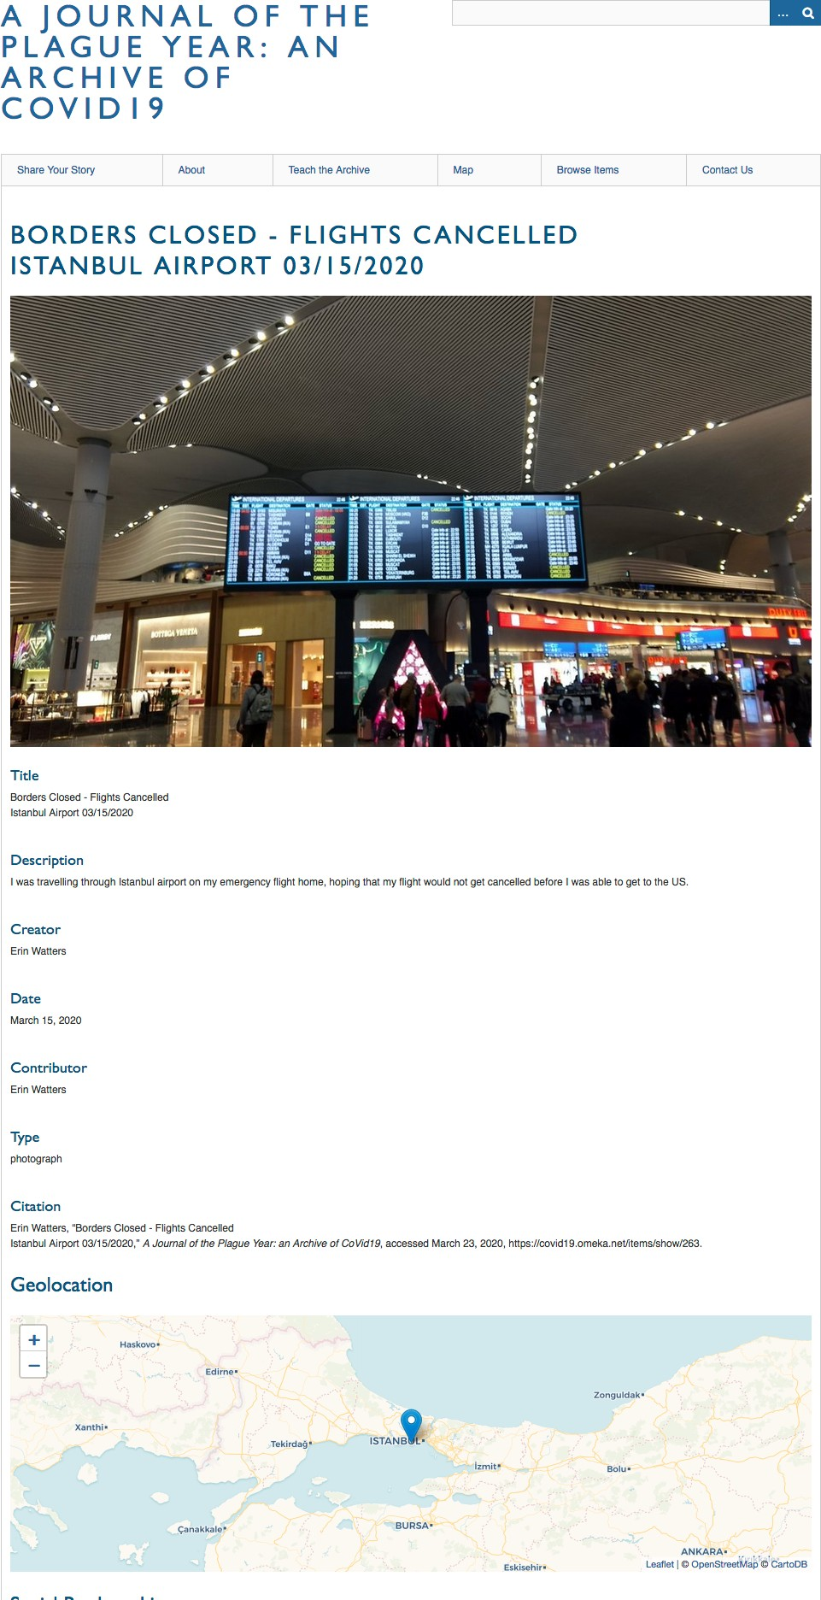
Title: A name given to the resource: that is, what are we looking at? Be specific.
Borders Closed - Flights Cancelled, Istanbul Airport 03/15/2020
Description: 1-5 sentences (may be edited for clarity)
I was travelling through Istanbul airport on my emergency flight home, hoping that my flight would not get cancelled before I was able to get to the US.
Creator: who created this item initially: Your name if you took the image, created the item itself; if the image was taken by someone else, from online, cite that person or the URL where obtained. Erin Watters
Date: a point in time associated with this item: when was this photograph taken? When was the article written? When was the information created, not necessarily when you saw it.
March 15, 2020
Type: what kind of thing is it? Photograph? Screenshot? Newspaper article? Website?
Photograph
Citation: this will automatically be created from info you provide. Geolocation: give an address where this item is located. So if the item is an image from the Jeff Road Price Right then what is the address of Price Right? If the item is a website article discussing a new COVID-19 treatment center in Boston’s Dorchester neighborhood, what is the address of that site? If the item is from your personal house and you don’t want to give your address, you can use a general city and state as the identifier.

Your name:
Your email address:
Anything else to say about this item?:

The https://covid19.omeka.net/ COVID-19 “Plague Year” community collaboration, and your experience gathering 5 items from your world, will enable us to contribute to a global project in the midst of a pandemic.

** Please note, your Discussion post for 4/16/20 refers to this experience and the COVID-19 Omeka site, so you need to complete this assignment before responding to the Discussion Post.

COVID Archive Assignment | MUSE 360 01 | Spring 2020-2195 | Decker 1 | 1

