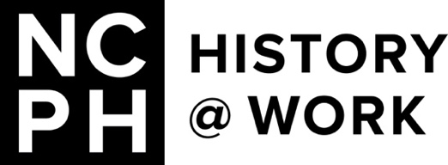

Call for History@Work Pitches

about Artificial Intelligence

and Public History

History@Work invites prospective volunteer authors to submit pitches, one-three paragraphs in length, about issues surrounding generative artificial intelligence (AI) in public history. Pitches might address topics including, but not limited to, generative AI and public history teaching; generative AI and the digital humanities; generative AI opportunities in public history; and generative AI challenges in public history as it relates to generation of text, images, or other media.

We are open to a variety of responses, but some specific issues we have been thinking about include:

- using AI to perform tasks including creating bibliographies, synthesizing historical sources, and/or generating historical interpretation
- assessing the problem of hallucinated source materials
- addressing the ethical and methodological challenges when using AI In the classroom
- accounting for the impact of AI on the labor market for public history and related fields
- identifying potential gaps between public expectations of the truthfulness of AI-generated content and content verified by traditionally cross-referenced historical methods
- revealing weaknesses in tools for vetting accuracy and promoting rigor, especially in public history narrative interpretation without direct citations
- developing critical perspectives on attempts to control generative AI’s propagation of biases by restricting subjects for exploration, making “difficult history” topics taboo and therefore reinforcing a sense that there are dangerous ideas that we shouldn’t talk about because they might cause harm (either personal harm or in the form of weakening perceived social cohesion)
- pondering the implications for public history of widespread biases (racism, sexism, ableism, ageism, nativism, etc.) and historical myths spreading via AI

We welcome diverse perspectives that contextualize contemporary issues related to generative AI within broader historical processes (such as the relationship between people and technology) and public history practice (such as the digital humanities or specific digital trends or projects). Prospective essays may have more than one author, and prospective contributors are welcome to propose Q&A interview formats on this topic. Read more about our pitch process here. Send pitches or questions to us at historyatwork@ncph.org.

