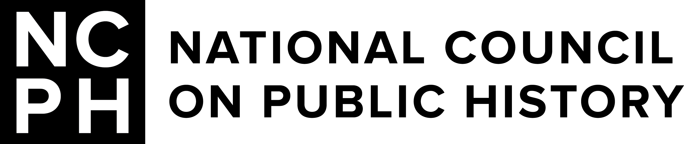**Solidarity | *Solidarité*  
National Council on Public History Annual Meeting  
Montréal, Québec, Canada | March 26-29, 2025  
Call for Posters**

**Deadline:** October 10, 2024 **Submission portal:** <https://ncph.org/conference/2025-annual-meeting/cfps/poster-proposal-form/>  
**Questions?** Email Meghan Hillman, NCPH Program Manager, [meghillm@iu.edu](mailto:meghillm@iu.edu)

## What is the NCPH Poster Session?

The NCPH poster session is a two-hour block of time at the annual meeting where presenters can share their projects with attendees in the form of a poster. It offers an alternative for presenters eager to share their work through one-on-one discussion, can be especially useful for works-in-progress, and may be a particularly appropriate format for presentations where visual or material evidence represents a central component of the project.

## When is the Poster Session?

The poster session will be held on Thursday, March 27, from 5:00-7:00 pm at le Centre Sheraton hotel in Montréal. Set-up will start an hour before the poster session begins.

How to Submit a Proposal  
Please fill out the online form at <https://ncph.org/conference/2025-annual-meeting/cfps/poster-proposal-form/>**.** Along with contact information and a brief (~300 word) explanation of your poster, we ask that you provide a one-page C/V for each presenter and a simple visual mock-up of your poster (saved and uploaded as a PDF).

## How Will Your Proposal Be Evaluated?

The Program Committee will consider the persuasiveness of your abstract, the quality of your proposed visual presentation, and your project’s relation to major issues and questions in public history.

## When is Your Proposal Due?

Poster proposals are due Thursday, October 10, 2024. You will hear back about the status of your proposal by the end of October. If accepted to the poster session, graduate students who are members of NCPH are eligible to apply for a [Graduate Student Travel Award](http://ncph.org/about/awards/student-awards/) by December 1.

## Is the Poster Session Right for Your Work?

Posters are an interactive and visual format for displaying and discussing project‐based work. In the sciences, posters are often a way to present preliminary data on a research topic and gather advice. Most posters for this conference will represent work that is complete, but we encourage submitters to present work as part of multi‐year or ongoing projects so they can solicit advice and resources at the conference.