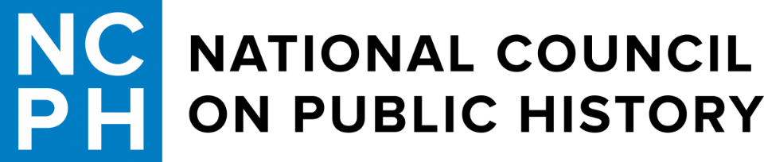

**CampingCon 2024 – *Wilderness and the Historian***

**Camp Thunderbird ǀ Mimbres, New Mexico**

**October 9-13, 2024**

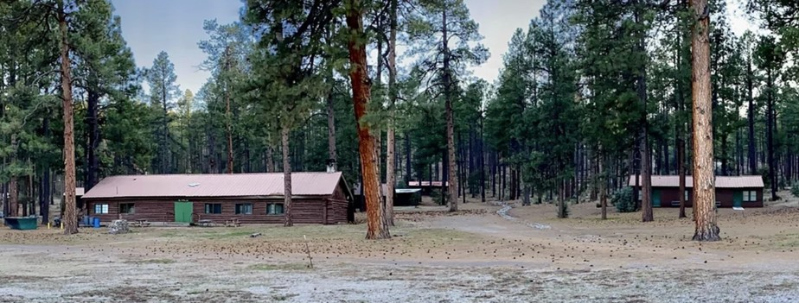

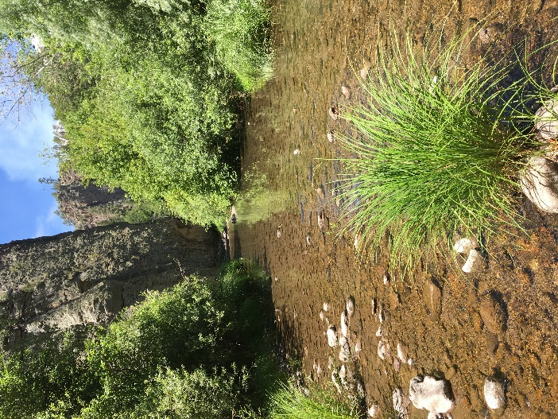 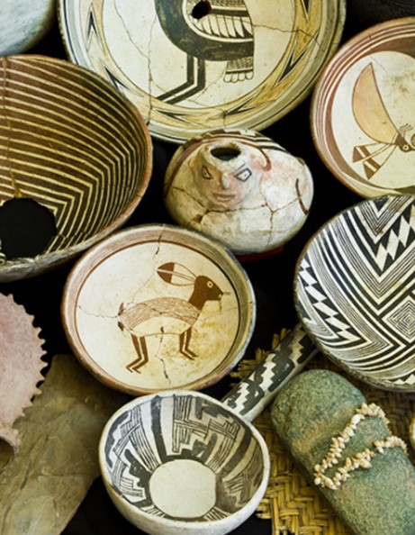 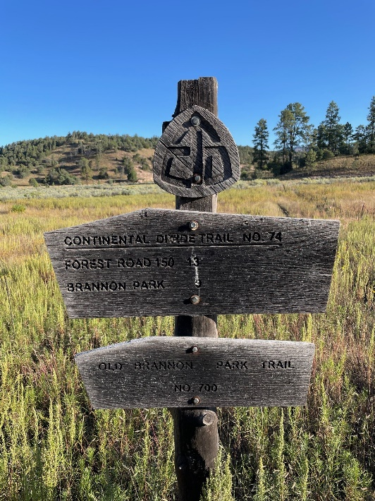

**Clockwise: Camp Thunderbird, Continental Divide Trail marker, Mimbres pottery, Gila River**

(Photos courtesy of Camp Thunderbird, Dylan McDonald, Western New Mexico University Museum)

Welcome to the Land of Enchantment

NCPH is back with another edition of CampingCon! This camping conference, set in the great outdoors, focuses on how historical education, interpretation, documentation, preservation, and scholarship can flourish in outside spaces. The foothills of the Black Range surrounded by the Gila National Forest in southwestern New Mexico offers a truly unique setting for public historians to gather together and discuss their work, studies, and research.

We’ve worked hard to craft offerings that are interactive, invigorating, and address the theme of *Wilderness and the Historian*. The theme calls attention to this year’s centennial of the Gila Wilderness, the country’s first such protected designation. We will hear from plenary speakers, Thora Padilla, President of the Mescalero Apache Tribe, and Priscilla Solis Ybarra, Associate Professor at the University of North Texas and scholar of Latinx literature and the environment. Panel sessions will discuss Aldo Leopold, John Muir, public lands as classrooms, outdoor memorials, indigenous peoples’ relationships with federal lands, and other topics. As a group we will visit the nearby Mimbres Culture Heritage Site and Historic Fort Bayard. Plan to participate in the morning hikes in the Gila Forest, evening campfire singalongs, and a moderated discussion on recent public history scholarship. Pre- and post-conference activities include hiking a portion of the Continental Divide Trail into the Gila Wilderness, taking in the Mogollon architecture at the Gila Cliff Dwellings National Monument, and a visit to nearby Silver City for meals and entertainment. We hope you enjoy your time at CampingCon 2024!

Dylan McDonald, New Mexico State University

Jeff Shepherd, University of Texas at El Paso

Land Acknowledgement

New Mexico State University honors Native American knowledges and worldviews based on intimate relationships to the natural world. The genesis of the Southwest Indigenous Peoples – including the Pueblos of Haak’u [Acoma], Ko-tyīt [Cochiti], Shiewhibak [Isleta], Walatowa [Jemez], Ka’wai’ka [Laguna], Nambé Owingeh, Ohkay Owingeh, Pe’ewi [Picuris], P’o-suwae-geh Owingeh [Pojoaque], Tuf Shur Tia [Sandia], Katishtya [San Felipe], Po-Who-Geh Owingeh [San Ildefonso], Tamaya [Santa Ana], Kah’p’oo Owingeh [Santa Clara], Santo Domingo, Taos, Tet-sugeh [Tesuque], Shiwina [Zuni], and Tsiya [Zia]; Fort Sill Apache Tribe, the Haisndayin [Jicarilla Apache Nation], the Mescalero Apache Tribe; and the Diné Nation – established their guardianship of the lands now occupied by New Mexico State University. As the state’s Land-Grant University, we acknowledge and respect the sovereign Indian Nations and Indigenous Peoples. We pledge to have a meaningful and respectful relationship with the sovereign Indian Nations, Indigenous communities, and Native American Peoples within the institution.

**Special thanks to Camp Thunderbird and those who organized and staffed the conference:**

*Fort Bliss:* Troy Ainsworth; *New Mexico State University:* Kevin Comerford, Dennis Daily,

Elizabeth Horodowich, Madison Marino, Dylan McDonald, Mackenzie Ross, Elizabeth Villa, Jerry Wallace;

*NCPH:* Meghan Hillman, Stasia Tanzer; *Southwest Environmental Education Cooperative:* Michelle Hall Kells;

*University of Texas at El Paso:* Jeff Shepherd, Benjamin Shultz

**Thank you to our financial sponsors who made this conference possible:**

New Mexico State University Department of History & the University Library

University of Texas at El Paso Department of History and College of Liberal Arts

Southwest Environmental Education Cooperative and Gila Ancestral Homelands

southwestenvironmentaleducationcooperative.org ǀ gilawildernesscentennial.wordpress.com

**Camp Thunderbird ǀ 3951 NM-35 Mimbres, NM 88049 ǀ (575) 536-9560** [**www.campthunderbirdnewmexico.org**](http://www.campthunderbirdnewmexico.org)

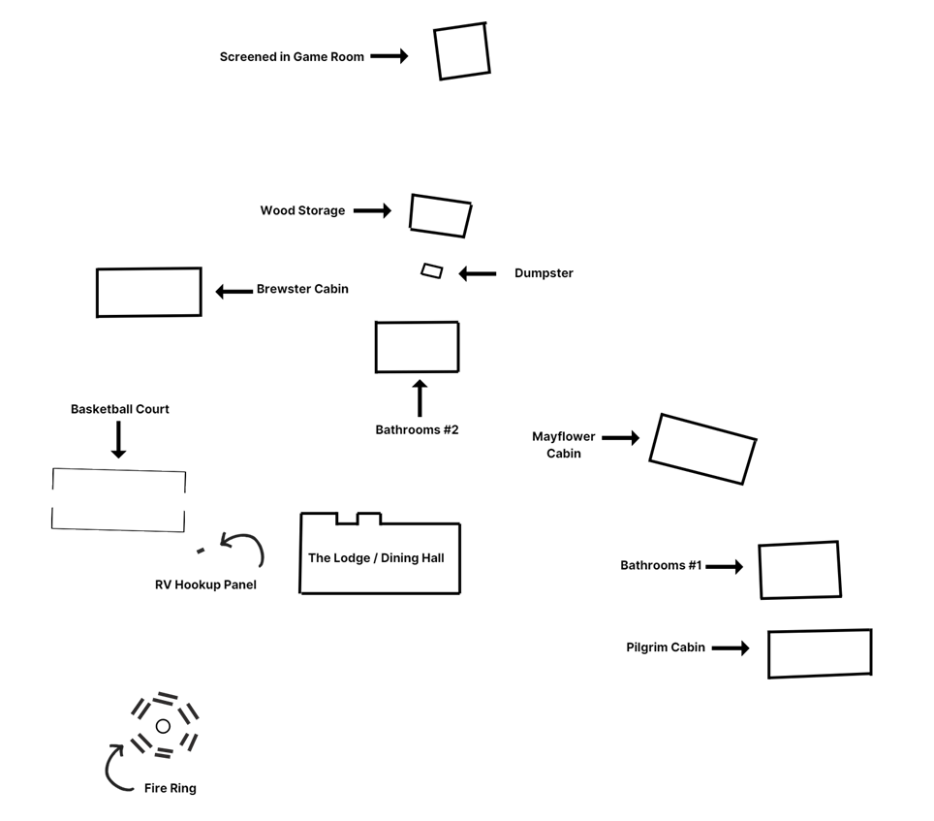

* Unless otherwise indicated all presentations take place in the Lodge or Game Room, and all meals in the Lodge.
* Pilgrim Cabin is male-only; Mayflower Cabin is female-only; and Brewster Cabin is gender-neutral.
* Those tent-camping should use the meadow between the Lodge and Highway 35.

__________________________________________________________________________________________________

Conference attendees are asked to assist NCPH in creating a “community of practice,” built on a foundation of trust, respect, optimism, and authenticity. This community is inclusive of all regardless of race, ethnicity, nationality, religion, gender identity, age, sexual orientation, marital status, ability, educational level, or stage of professional development.

If you experience an incident of harassment or other unprofessional conduct, please contact

Dylan McDonald at dylanmcd@nmsu.edu or Stasia Tanzer at atanzer@iu.edu.

*Note: Activities before noon, Thursday October 10th and after 1:00 p.m., Saturday October 12th may incur additional fees. Meals during pre- and post-conference periods are not provided as a part of registration.*

**Wednesday, October 9**

**12:00 p.m. Camp Thunderbird Opens**

**4:00 p.m. Dinner carpools**

**Arenas Valley** (41 minutes – 31 miles) [Whiskey Creek Zócalo](https://www.whiskeycreekzocalo.com/)

or

**Pinos Altos** (53 minutes – 40 miles) [Buckhorn Saloon & Opera House](https://www.facebook.com/buckhornsaloonandoperahouse/)

**7:30 p.m. Film Screening (Lodge)**

[***Salt of the Earth***](https://youtu.be/FE1oKQCwwo4?si=_QTUja5wBwGnfuGX)(1h 34m)

A dramatization of the 1951 strike by the Mexican-American miners of Grant County, New Mexico against the Empire Zinc Company. One of the first Hollywood films to advance a political and feminist point of view, for which the work and those involved with its production were blacklisted, the film was added in 1992 to the [National Film Registry](https://loc.gov/programs/national-film-preservation-board/film-registry). The strike is the focal point of an ongoing regional public history project – the [Salt of the Earth Recovery Project](https://saltoftheearthrecoveryproject.wordpress.com/).

**Thursday, October 10**

**6:30 a.m. – 10:30 a.m. Hike along the Continental Divide Trail (CDT) into the Gila Wilderness (Lodge)**

A moderate 5-mile out-and-back guided hike with less than 300’ elevation gain, the route follows along [Section 9 of the CDT](https://www.alltrails.com/trail/us/new-mexico/cdt-section-9-new-mexico-highway-35-to-rocky-point-forest-road-150) in New Mexico. Just 10 minutes north of the camp, hikers will proceed from Highway 35 into Rocky Canyon, crossing the Gila Wilderness boundary after the first ½ mile. The canyon narrows as the hike proceeds past cairn markers, through sections of pine forest and open floodplain, culminating in a riparian area next to a flowing stream. Participants should be generally fit and prepared for moderate inclines and uneven terrain; dress in layers, bring at least 32 oz. of water, apply sunscreen, and have proper hiking footwear. Gather in the Lodge for instructions before departing.

**9:00 a.m. – 1:00 p.m. Check-In/Registration (Lodge)**

**__________________________________________________________________________________________________**

**Noon – 1:00 p.m. Lunch (Lodge) – Enchiladas, salad, chips, and drinks**

**1:15 p.m. – 2:15 p.m.**

**Session 1 (Lodge): Aldo Leopold**

*Aldo Leopold’s New Mexico Years: The Most Important Time of His Life*

Stephen Fox, Independent Historian

Aldo Leopold, fresh out of the Yale Forest School, got off the train in Albuquerque in 1909 and began the most momentous fifteen years of his life. Here he began his slow evolution from the selfish, human-centered version of conservation that he had learned at Yale to the radical, nature-centered vision that informed his classic book, *A Sand County Almanac*. Aldo made a permanent connection to New Mexico by meeting and marrying Maria Alvira Estella Bergere of Santa Fe. On her mother’s side, Estella was part of the Luna family, one of the old Hispano clans of New Mexico. The marriage was conspicuously happy. Four of their five children were born during Aldo’s time here. In September 1909 he had his famous encounter with the “fierce green fire” in a dying wolf’s eyes—which, years later, came to seem life-changing. And in 1924 he made his first original contribution to conservation practice by getting the initial designated “wilderness area” established on part of the Gila National Forest.

**2:30 p.m. – 3:30 p.m.**

**Session 2 (Lodge): Silver City, New Mexico**

*How the Gila Forest Saved Silver City*

Susan Berry, Historian and Preservationist

Floods became a regular occurrence in Silver City soon after its founding in 1870. Set in a valley edged by mountains, the town had been platted in a tidy grid without consideration of natural drainage patterns. Three decades later the timber, grasses, and shrub growth in the surrounding region were heavily depleted, even as flooding increased both in frequency and severity. By the 1890s the summer monsoons’ arrival was sardonically termed the “flood season.” Residents failed to connect the annual deluges with watershed degradation. They instead focused on protecting property with breakwaters, flumes, dams, and bridges, only to see these improvements wash away. The face of Silver City was forever altered in 1902, when Biblical-scale flooding transformed Main Street into a yawning chasm literally overnight. Soon dubbed the Big Ditch, the gulch continued to widen and deepen despite efforts to retain its banks. Upstream, however, the trend was starting to reverse. The much-resented regulations imposed with establishment of the Gila Forest Reserve in 1899, along with replanting and erosion abatement undertaken in the early 20th century, ultimately brought healing to the watershed. The Big Ditch, a valuable channel for storm runoff, is now a downtown park connected to local trails.

*Seeing the Forest for the Trees: The Silver City Museum*

Bart Roselli, Director, Silver City Museum

The Silver City Museum had faced sagging membership levels and limited community support before changing its focus and operations to become accredited by the American Alliance of Museums. New museum leadership committed to an effort of widespread involvement of stakeholders. Staff realized that its program and exhibit offerings did not attract nor serve a representative cross section of the region’s citizens. An oral history project to document Silver City’s oldest and most overlooked neighborhood was a first step in a rebuilding. With this project it adopted a strategy of embracing deeper, homegrown scholarship, and engaging a wide and diverse cohort of community members. It adopted a team approach to exhibit and program development and began a long-range planning effort to select major new exhibition topics. As part of this rebuilding, it developed a set of seven interpretive themes to guide future explorations of local history and culture. The change also included many professionalizing actions like crafting a new mission, developing clear emergency protocols, prioritizing collections management actions, and launching a visitor studies effort. This presentation will share the principles and methods the museum used to reconnect and reinvigorate its position in the community and will address some of the challenges faced by and still facing the museum.

**4:00 p.m. – 5:00 p.m.**

**Session 3 (Lodge): Interpreting Place**

*Segregation, Memory, and the Role of Public History at Oklahoma’s Lake Murray State Park*

Trevor Egerton, Ph.D. Candidate, History Department, University of Colorado Boulder

In southern Oklahoma, off the shoulder of the Arbuckle Mountains and encompassing an eponymous lake, sits Lake Murray State Park. After Lake Murray’s opening in June 1938, the state segregated one-third of the park for African American recreationalists who had access to a Civilian Conservation Corps (CCC) constructed group camp, a Meinecke-style loop campground, and a portion of the lakeshore. Part of a broader system of approximately forty segregated state parks across the Jim Crow South between 1935 and 1964, Lake Murray served both as an important Black-only site of community and, by 1952, a place of protest for equal access until desegregation five years later. Yet, the history of Lake Murray—as portrayed on park signage, online guides, and the Oklahoma State Parks website—describes the CCC heritage of the park while fully ignoring Lake Murray’s racial history. First, I discuss how the suppression of this history has shaped our perception of outdoor recreation as a white-only pursuit. Second, I interrogate the role of public historians in park histories, seeing if we could bring back the “millionaire’s rest”; an evocative phrase one African American visitor used to describe Lake Murray State Park.

*Conservation in the Colony: Forging and Contesting Public Lands in Puerto Rico*

Alex Standen, Visiting Assistant Professor, Department of History, New Mexico State University

Public lands in Puerto Rico are bitterly contested. In an archipelago often called “the world’s oldest colony,” questions of who owns the land, who has access to it, and who bears responsibility for managing it take on a special significance. This talk examines the history and present of public lands in Puerto Rico through three case studies. First, it looks at the creation during the New Deal period of five federally-funded state forests in the Puerto Rican mountains. These forests were established to protect the watersheds that surrounded newly-constructed hydroelectric dams that reformers envisioned as a path to energy sovereignty and greater economic independence from the US. Second, it analyzes the establishment in 2001 of the Vieques National Wildlife Refuge on toxic lands previously used by the US Navy to drop bombs, fire missiles, and practice land-sea combat. The “wildlife refuge” designation has effectively blocked public access to huge portions of Vieques and obscured the federal government’s responsibility for cleaning up the undetonated landmines and toxic chemicals that mar the landscape. Finally, the talk will examine present-day protests against tourism development projects that block public access to Puerto Rico’s beaches. Along the way, we’ll explore the way public lands have been used to both build and undermine Puerto Rican sovereignty, and we’ll look at how Puerto Ricans experience these lands in the present.

**5:30 p.m. – 6:30 p.m. Dinner (Lodge) – Lasagna, garlic bread, salad, drinks, and dessert**

**7:00 p.m. – 8:00 p.m.**

**Plenary A (Lodge): Thora Padilla –** *Ways of Seeing Wilderness and Stewardship of Tribal Lands into the Future*

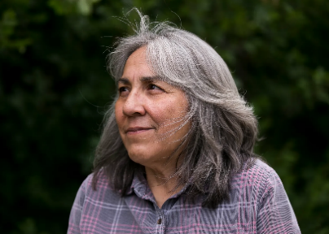Thora Padilla became president of the Mescalero Apache Tribe on January 12, 2024. Prior to that she worked for the tribe as Director for the Division of Resource Management and Protection. She helped to establish and develop the program, which began as the Office of Environmental Protection in 1994. She also worked for eight years with the Bureau of Indian Affairs, Mescalero Agency as a Timber Sale Forester. Ms. Padilla has served on the New Mexico State Parks Advisory Board, the US Forest Service Collaborative Forest Restoration Program Technical Advisory Panel, and the Natural Resource Conservation Service Western Regional Tribal Conservation Advisory Council. She graduated from New Mexico State University in 1985 with a Bachelor of Science in Agriculture, with a major in Horticulture, and minors in Botany and Fine Art.

**8:30 p.m. – Late Campfire Discussion & S’mores (Fire Ring)**

Attendees are invited to share with the group recent public history scholarship that has informed their work. This can be anything from a recent book or article in *The Public Historian* to a museum exhibit or community project. This is an informal discussion, no need to prepare anything, just a willingness to share your thoughts and eat s’mores!

**Friday, October 11**

**6:30 a.m. – 7:00 a.m.** **Morning Hike (Lodge)**

This moderate guided hike will proceed along trails and fire roads behind the Camp and explore the nearby Gila Forest.

**7:00 a.m. – 8:00 a.m. Breakfast (Lodge) – Breakfast burritos with salsa, fresh fruit, cold cereal, and coffee & juice**

**8:30 a.m. Departure for Historic Sites (Lodge)**

Bring 32 oz of water, jacket, hat, sunscreen, and snack.

**9:00 a.m. – 10:30 a.m.**

**Session 4 (Mimbres):** [**Mimbres Culture Heritage Site**](http://www.mimbrescultureheritagesite.org/)

*Two Thousand Years of Mimbres Stories*

Bill Hudson, President, Imogen F. Wilson Education Foundation

The Mimbres Culture Heritage Site is known as the only publicly accessible interpretive Mimbres Pueblo. It is far more than that. It represents two thousand years of almost continual occupation in this one location. That one location is representative of the vibrancy of this rich region. Prehistorically, the valley would have been a wonderful hunting ground. Then the Mogollon Culture found it to be an ideal location to establish early agriculture, eventually leading to the uniqueness of the Mimbres Puebloans within the Mogollon sphere. As the Mimbres flourished and then faded, new peoples arrived. Each placing their own stamp on the wilderness.

**11:00 a.m. – 12:30 p.m.**

**Session 5 (Fort Bayard):** [**Fort Bayard Museum and Fort Bayard National Historic Landmark**](https://www.historicfortbayard.org/)

*A Walk-Through History: Outdoor Interpretation at Fort Bayard National Historic Landmark*

Dr. Douglas Dinwiddie, President, Fort Bayard Historic Preservation Society

The Fort Bayard Historic Preservation Society is an all-volunteer organization formed in the 1990s to preserve and interpret the story of Fort Bayard for current and future generations. Central to its mission is telling the story of two distinct eras in the facility’s history: As a frontier military post from 1866-1899, and a medical facility from 1899-2010. Dr. Dinwiddie will provide a tour of the museum and grounds of Fort Bayard. During the tour he will explain the process of the development of the interpretive signage and walking tour booklet, and provide details on how the interpretive plan was conceived and implemented, in order to accurately reflect the facility’s story.

**12:30 p.m. Depart for Camp Thunderbird & Lunch – Cold cut sandwiches, chips, and drinks**

**2:00 p.m. – 3:30 p.m.**

**Session 6A (Lodge): Public Land Paradigms**

*Representing Wilderness & Shifting Public Lands Paradigms in U.S. Public Lands Artist-in-Residence Programs*

Hardt Bergmann, Ph.D. Candidate, Department of Geography, New Mexico State University

Eric Magrane, Associate Professor, Department of Geography, New Mexico State University

The arts have long played a crucial role in representing and shaping perceptions of wilderness and public lands. Currently, over seventy U.S. public lands have some form of artist-in-residence (AIR) program. We will share and discuss our current research on these artist-in-residence programs, drawing on multiple threads: 1) background research on these programs; 2) Magrane’s experience as an AIR in three programs; and 3) our research on the AIR program at Organ Mountains-Desert Peaks National Monument (OMDP) in southern New Mexico, in which we have conducted field and sit-down interviews with artists and program administrators. Public lands embody important questions about the U.S.’s past, present, and future, including debates over public and private lands, contested histories, challenging resource management questions, and diversity and access. We propose that AIR programs have the potential to bring to the fore an aesthetic epistemology that can influence management, public education, and engagement efforts in a nuanced manner that moves past simple boosterism or simplistic conceptions of wilderness and the outdoors.

**Session 6B (Game Room): Connections to Public Lands**

*How Do you Solve a Matter Like John Muir?*

Mike Wurtz, Head of University of the Pacific Holt-Atherton Special Collections & Archives

Famed naturalist John Muir attended the “University of the Wilderness” on his way to preserving thousands of acres of land to "conserve the scenery” and leave it “unimpaired for the enjoyment of future generations.” Within the last generation or so, Muir has come under increasing examination as detractors and supporters attempt to parse and understand his 19th-century language and values around race and indigenous peoples in particular. The [University of the Pacific](https://www.pacific.edu/university-libraries/find/holt-atherton-special-collections/muirexperience) has been the home of the largest collection of Muir archives including his journals and notebooks, correspondence, drawings, and unpublished manuscripts since 1970. I will trace the historiography of Muir in the context of race; how UoP established a museum to Muir’s archives in context; and the challenges of working with researchers that are both supporters and detractors of Muir, in an attempt to solve the matter of John Muir.

*Conserving Ancestral Connections Through Action and Dialogue*

Kyle Trujillo, Senior Program Director, [Ancestral Lands Conservation Corps](https://ancestrallands.org/)

The dominant paradigm of American conservation is at odds with Indigenous ways of thought and being. Because of the edificial power of these reified beliefs, disruption is a daunting prospect that Indigenous public service professionals are met with daily, both in terms of its practical and conceptual demands. In practice, the challenge is to disrupt while affirming; to not only negate and counter, but to develop positively all the while. ALCC endeavors to actualize a conservation approach that disrupts harmful perpetuation of production-focused ideologies while affirming ancestral methods of being in relationship with the world. Conceptually, analyzing the roots of common-sense notions of conservation, growth, and capacity is nothing less than re-evaluating our reasons for being. Because our program is intended to prepare young people with tools to create sustainable lives for ourselves and our families, the values conflict of land use directly relates to the safety and efficacy of the future generations of land stewards. Empathy is our path: to learn about ALCC is to learn with us. Through guided discussion, we will learn about our respective organizational practices toward ethically realizing the blessing of long life for all.

*“Just Ski”: The Past, Present, and Future of New Mexico Skiing*

Heather McClure, Librarian & Archivist, Museum of New Mexico

New Mexico ski history is rife with plucky outdoorsmen, European expatriates, and intrepid Army veterans. Robert Nordhaus (Albuquerque Ski Club) and Ernie Blake (Taos Ski Valley) skied in Europe and brought the love of the sport with them to the Southwest. While it takes fortitude to climb New Mexican heights such as Albuquerque’s Sandia Peak (10,678 feet elevation) on seven-foot-long skis, it took a lot more than guts to build those first runs into the thriving $2.3 billion-dollar state outdoor economy. Homestead Act claims staked valuable mountain property. National Forest Service land use collaborations began in the 1930s. The Civilian Conservation Corps built ski area structures. The U.S. Army trained a generation of skiers in the 10th Mountain Division. However, the days of abundant snowfall, and a laid-back vibe are changing. Western States battle over every drop of remaining steady water sources. Environmentalists, Tribes, and Pueblos are pushing back on the mountain construction projects, like new lift lines, required to keep ski facilities economically competitive. Looking at contemporary news sources, stories from New Mexicans, and evaluating natural resources information, this presentation will look critically at skiing in New Mexico and its past, present, and future impact on the state.

**3:45 p.m. – 5:15 p.m.**

**Session 7A (Lodge):** [**The Gila Film School**](https://www.facebook.com/p/Gila-Film-School-100082969040847/)

*What We Hold Sacred (Behind the Scenes)*

Araceli “Blue” Hernandez, Filmmaker, New Mexico State University

*To Love A River*

Samantha Jaso, Producer/Director, New Mexico State University

The Gila Film School was an immersive multi-semester program through New Mexico State University’s Creative Media Institute. Led by Ilana Lapid and Kristi Drexler, the project partnered with the [U.S. Forest Service](https://www.fs.usda.gov/detail/gila/learning/history-culture/?cid=fseprd1202132) to bring student filmmakers into the Gila landscape and be inspired to tell documentary stories. “The objectives of the Gila Film School were fourfold,” said Lapid, Gila Film School director and CMI professor. “Our goal was to connect students to the wilderness, empower the next generation of diverse environmental filmmakers, harness the power of visual storytelling for conservation education and inspire audiences of young people to love and protect the wilderness.” In this session, two student filmmakers will show their films: “What We Hold Sacred (Behind the Scenes)” follows a group of 13 New Mexico State University students as they venture out into the Gila Wilderness in an effort to film six documentaries during the first ever Gila Film School, and “To Love a River” a film that emphasizes the importance of preserving the Gila River for both present and future generations. Through powerful storytelling, the film reminds us that protecting the Gila River is not just an environmental issue, but a vital responsibility to uphold the cultural and ecological heritage it sustains. It achieves this not only by highlighting the river’s natural beauty but also by celebrating the diverse communities it unites. After screening the films, the filmmakers will discuss what inspired their creative work and will have a Q&A with the audience.

**Session 7B (Game Room): Water Ecologies**

*Fluid Geographies: Settling New Mexico During the Reclamation Era*

Maria Lane, Professor of Geography & Environmental Studies, University of New Mexico

This presentation traces New Mexico’s transition from a community-based to an expert-led system of water management during the pre-statehood era. It draws on Lane’s 2024 book *Fluid Geographies* to examine the primary conflict of the time, which pitted Indigenous and Nuevomexicano communities, with their long-established systems of irrigation management, against Anglo-American settlers, who benefitted from centralized bureaucratic management of water. The newcomers’ system eventually became settled law, but water disputes have continued ever since. The presentation uses a fine-grained analysis of legislative texts and nearly two hundred district court cases to illuminate cultural patterns and attitudes toward water use and management in a pivotal time in New Mexico’s history. Illuminating complex themes for a general audience, *Fluid Geographies* helps readers understand how settler colonialism constructed a racialized understanding of scientific expertise and legitimized the dispossession of nonwhite communities in New Mexico.

*Connecting to Gila: The Body as a Vehicle for Reconnection to Land*

Sandra Paola López Ramírez, Visiting Assistant Professor, Department of Theater and Dance, University of Texas at El Paso

This will be a participatory presentation where we will explore the embodied methods developed through the multi-year interdisciplinary project [Experiencing the Bosque](https://www.utep.edu/rubin/community-engaged-practices-in-the-arts1/experiencing-the-bosque.html) (ETB) in the context of the Gila Wilderness. As a multigenerational project radically integrating community organizing, art-making and environmental stewardship, ETB is grounded on embodied practices that reconnect us to land and what Robin Wall Kimmerer calls “more-than-human nature.” ETB is a deep investigation of the Rio Bosque Wetlands Park— a 372-acre public park and ecological restoration project of the Rio Grande/Rio Bravo valley ecosystem in El Paso, TX— and its aim has been to support a meaningful reintegration of our species into our local ecosystems. Drawing from my experience as a dancer, movement-based interdisciplinary artist and leader of ETB, I will share this research while guiding participants through their own embodied exploration of the Gila Wilderness.

**5:30 p.m. – 6:30 p.m. Dinner (Lodge) – Grilled chicken, roasted potatoes,** **salad, drinks, and dessert**

**7:00 p.m. – 8:00 p.m.**

**Plenary B (Lodge): Priscilla Solis Ybarra** – *The Idea of Wilderness for Mexican Americans*

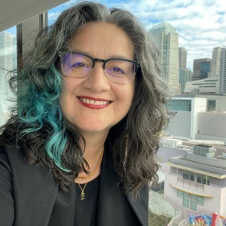Priscilla Solis Ybarra is Associate Professor in the Department of English at the University of North Texas, where she teaches Latinx literature and environmental humanities. Her first book, *Writing the Goodlife: Mexican American Literature and the Environment*, won the Thomas J. Lyon Book Award in Western American Literary and Cultural Studies. Her co-edited collection *Latinx Environmentalisms: Place, Justice, and the Decolonial* was chosen for the inaugural 2022 Modern Language Association Prize for an Edited Collection. She serves on the Editorial Board for the journal *ISLE: Interdisciplinary Studies in Literature and Environment*. She lives on unceded Wichita and Caddo lands not far from where she was born on the southern bank of the Trinity River, to a Mexican immigrant mother and a second-generation Mexican American father.

**8:30 p.m. – Late Campfire Music & S’mores (Fire Ring)**

Join us as New Mexico State University’s Dennis Daily and Rus Bradburd – professors by day, musicians by night – lead us through American and Mexican folk and old timey tunes. Feel free to sing along!

**Saturday, October 12**

**6:30 a.m. – 7:00 a.m. Morning Hike (Lodge)**

This moderate guided hike will proceed along trails and fire roads behind the Camp and explore the nearby Gila Forest.

**7:00 a.m. – 8:00 a.m. Breakfast (Lodge) – Egg casserole, home fries, meat, and** **cold cereal, and coffee & juice**

**8:30 a.m. – 10:00 a.m.**

**Session 8A (Lodge): Teaching with Public Lands**

*Students, Lions, and Bears!*

Travis Perry, Professor, Department of Biology, Furman University/Natural Curiosity

Nothing has the same impact as experiential education. For twenty-five years I have had the privilege of teaching students the complexities of ecology, the practice of conservation, and the skills necessary to conduct research in the wild. I have taught them backcountry ethics and wilderness skills that turn a fear of the wild into a love of the wild and that has turned timidity into self-confidence and self-reliance. The centerpiece of my teaching career has been the Wild Semester, taught since 2005 at Hermosa, New Mexico, on the eastern edge of the Aldo Leopold Wilderness in the Gila National Forest. In 2021 I was given the opportunity to acquire this property for continued and expanded use as a conservation research and education facility. In response, we created a non-profit organization, [Natural Curiosity](https://www.natural-curiosity.org/), for that purpose. It is our intention to partner with like-minded individuals, organizations, and agencies in the Gila region to host and/or facilitate research projects, educational programs, and conservation work from trail maintenance to biodiversity surveys, as well as to conduct our own activities in this vein.

*The Archaeology of Trails: Hiking, Camping Along, and Backpacking the Continental Divide National Scenic Trail as Landscape Archaeology*

Troy Lovata, Professor, Honors College, University of New Mexico

For five years undergraduates in the University of New Mexico’s Honors College seminar *The Archaeology of Trails* have been walking portions of the Continental Divide National Scenic Trail in New Mexico; including weekend-long camping and hiking trips through El Morro and El Malpais National Monuments—where the CDT overlays numerous historic trails—and four days backpacking in the San Pedro Parks Wilderness Area—where historic land use is giving way to recreation. This is a landscape archaeology course about walking in place. Students examine prehistoric, historic, and contemporary trails as sites of placemaking and link artifacts—impacted soils, rock cairns, graffiti—to how different peoples around the world and across time define themselves and culturally construct their environment through walking it. Because it attracts a wide range of majors and backgrounds in the wilderness (few are Archaeology or Anthropology majors, some never camped before, others are experienced through-hikers), the seminar also lets students use walking as a methodology to explore their own relationships with natural and built environments. This presentation uses an interdisciplinary seminar as comparative fodder for how the public at large might understand histories of people and nature through a phenomenological experience of trails.

*Fostering a Love of Wild Places Leads to Protection of Wilderness*

Patrice Mutchnick, Board Chair, Heart of the Gila

Learning in the out-of-doors is the primary pathway for fostering an appreciation of the natural world. [Heart of the Gila’s](https://heartofthegila.org/) (HOTG) philosophy centers love of place as the primary driving force behind the protection of Wilderness and wild places. HOTG is located at the headwaters of the Gila River in the heart of the Gila Wilderness and has as its mission the protection of wild places in the Southwest. We strive to achieve this goal by conserving our watershed and educating children, adults, and decision makers about the ecological, social, economic, and cultural values of rivers in New Mexico and the bioregions of the greater Southwest. As such, our education programming uses watersheds as its organizing theme, and we implement activities based on explorations and stewardship, as the primary vehicle for promoting and spreading the mission of the protection of the Gila Wilderness.

**Session 8B (Game Room): Nature’s “Resources”**

*Challenging Extraction: The Fight to Stop Extractivism in the Gila National Forest and Wilderness (1905-1964)*

Benjamin Shultz, Ph.D. Candidate, Department of History, University of Texas at El Paso

The region surrounding the area that would become the Gila National Forest is full of minerals and natural resources that have been sought after for decades. Since the mid to late 19th century, prospectors and mining corporations have sought to control the land and extract the precious copper and zinc underneath the forest and wilderness region. The creation of the national monument in 1905 and the two subsequent wilderness areas in the 1920s hoped to preserve the region’s natural beauty against the ever-encroaching mining industry. Yet the legal framework of these designated areas was dubious at best and loose definitions of “conversation” allowed mining corporations to continue to mine and make claims even in the least valuable regions of the parks and wilderness. The decades-long physical and legal battle between the NPS, Wildness, and mining corporations would culminate in the 1964 Wilderness Act which finally defined the region and looked to make it a completely preserved area from the likes of aggressive mining companies. This presentation will chronicle the struggle between state, federal, and corporate battle over this contested space and the efforts of naturalists and conservationists to preserve the region and the consequences that emerged as a result.

*Shifting Values, Changing Borders: The Evolution of Joshua Tree National Park*

Sawyer Castleberry-Backman, MA student, Department of History, North Carolina State University

Joshua Tree National Park (formerly Joshua Tree National Monument) is considered one of the jewels of the National Park system, but it was not always so universally recognized by the Federal government and the Park Service. The fight to create and then maintain Joshua Tree reveals a larger relationship between the National Park System and the defense of the nation. The border changes that occurred to create the park boundaries that we recognize today tell a story of miners’ rebellion, military need, and Indigenous land rights. Through the examination of newspapers, legislation surrounding mining and desert protection, and the National Park’s founding documents, this paper argues that Joshua Tree is not just a “park for the people” but is also a natural resource for the federal government to extract whenever it is needed. Additionally, this paper works to fill a gap in the historiography by drawing connections to the removal of the Serrano (Maara’yam), Chemehuevi, Cahuilla, and Mojave (Pipa Aha Macav) peoples to create accessible land for white homesteaders and miners to the larger story of Joshua Tree. The park’s changing borders in 1936, 1950, and 1994 show how the extraction of resources and the waiver of environmental protections are prioritized over the preservation of the park.

*This Land is…: A Facilitated Discussion on Uses of Nature, Colonial Violence, and Loss*

Tanmai Vemulapalli, MA student, Department of History, North Carolina State University

I will facilitate a structured conversation that reflects on the juxtaposition of “wilderness” as a place of agency and violence–as in the nearby Sonoran Desert that absorbs the blame of political action for killing migrants–and as a passive resource that facilitates healing and health. Who encounters these various forms of wilderness? What violence underlies their maintenance and how is it made “invisible”? We will delve into the purpose and effects of the myth of “wilderness,” impulses of exploitation versus conservation, and the relationships to nature, environmental (mis)management, and indigenous communities. Within this conversation, we will also consider themes of disability and loss as they relate to wilderness (and the violence of wilderness). Collectively, we are witnessing and experiencing great loss from colonial violence. In addition, I am personally contending with what it means to become more disabled as the years pass. In cases of loss and grief, many advise communing with nature, being among the trees. How can we make space together for 1) feelings of loss, anger, and grief, and 2) intellectual engagement with “uses” of nature and accessibility and disability in the “wilderness”?

**10:30 a.m. – 12:00 p.m.**

**Session 9A (Lodge): Public Land and Commemorations**

*Life on the Edge…of the Wilderness: Narratives of People, Nature, and Place through the Farm Security Administration Photographs of Russell Lee*

Brian Forist, Senior Lecturer & Program Coordinator, Parks, Recreation, & the Outdoors, Indiana University

In 1937, the Farm Security Administration (FSA) was established as one in the alphabet soup of federal New Deal agencies created to turn the tide on Great Depression-era rural poverty during the tenure of President Franklin D. Roosevelt. The U.S. Library of Congress holds a large collection of FSA photographs, including those by noted photographer Russell Lee. Lee’s photographs include many taken near New Mexico’s Gila Wilderness as well as throughout New Mexico and beyond. In this session, participants will be oriented to FSA photographs and those taken by Mr. Lee as well as other materials relevant to researching and presenting this fascinating collection and its associated stories. Most photographs have a title with little additional descriptive content. Methods of contextualizing the photographs and creating potential narratives about people, nature, and place on the edge of the Gila Wilderness will be undertaken by participants. Included will be a discussion of ways to bring a photograph collection to life in public history settings.

*South by Southwest: Public Statues, Monuments, and Memorials of Texas and New Mexico*

Spencer Herrera, Professor, Department of Languages & Linguistics, New Mexico State University

In the South it is common to find Confederate monuments and memorials that idealize or romanticize our past. In other parts of the country there also exist memorials to Confederate soldiers and officers that have been neglected and left to fade into history. This is the case in El Paso, TX where a small granite memorial dedicated to Captain James W. Magoffin sits across a cement memorial dedicated to the Juan de Oñate expedition crossing. Both memorials are located in an abandoned piece of property known as Hart’s Mill, which abuts the U.S./Mexico border. Magoffin’s exploits took place before and during the Civil War. The Oñate expedition crossed the Río Grande into present-day Texas in 1598. They seemingly have nothing to do with each other, except for their shared location. Interestingly, there is a larger bronze statue (the largest bronze equestrian statue in the world) dedicated to Oñate at the El Paso airport, which has a controversial history. In this presentation I will discuss the issue of space, cost, and artistry of statues/monuments and how that can be more divisive and/or exclusive than the historical representation itself.

*Commemorating Mimbres: A Zine Project*

Kendall Lovely, Ph.D. Candidate, History Department, University of California Santa Barbara

Following the tradition of informational pamphlet, travel guide, or brochure, this interpretation of Mimbres/Mogollon material will take the form of a small piece of ephemera--a zine, or a do-it-yourself intervention on authoritative forms of disseminating basic knowledge to the public. Zines use collage and drawings combined with short text in an accessible and easily distributable manner. With the combination of visuals and text (similar to labels), the zines will work as portable exhibits that can be read in the space of the Gila Wilderness (or anywhere!). The zine serves as a disruption of “official” narratives that might be found in tourist materials toward critique of the displacement of ancient materials from the land into museums and private collections. This zine will consider the ethical issues around artifact looting and anthropology, for instance dealing with the controversy of provenance from burials, as well as other removals through commercial appropriation of Mimbres pottery imagery—but also reclamations, including examples of Indigenous artists referencing their ancestral cultures. Only a few zine copies will be available during the presentation (to reduce chances of inadvertent litter). I will also invite contributions to a sequel zine through which audience members can submit their own reflections.

**Session 9B (Game Room): Apache Landscapes**

*A Pre-Gila Wilderness Identity*

Ruben Leyva (Chihene Ndé Nation), Ph.D. Student, Department of Native American Studies,

University of New Mexico

At 100, the Gila Wilderness has become a fixture in the modern Southwest. The Wilderness Act of 1964 cemented the idea of “wilderness” into forest recreation policy. The Gila Apache people, for whom the wilderness has borrowed its name and land, have a long history in the Upper Gila and Mimbres watersheds and signed treaties in 1853 and 1855 to preserve that relationship. Federal leaders later erased the distinction between regional Apache groups, combining them under the name Chiricahua, thereby confusing the history and cultures of Apache people in today’s southern New Mexico. As a Ph.D. student at UNM, I am working to clarify how the federal government has wrongly associated the Gila Apache with the currently federally recognized groups in Mescalero and Fort Sill. We are seeking federal acknowledgement, a return of stewardship over our homelands, and the future preservation of our culture. My presentation will focus on the evidence and the tribe’s federal petition for recognition.

*Wendell Chino, the Mescalero Tribe, and Native Sovereignty*

Jeff Shepherd, Professor, Department of History, University of Texas at El Paso

This presentation focuses on the legacy of Wendell Chino, who was President of the Mescalero Apache Tribe for over 40 years. While he held leadership positions at the tribal, state, and national level, this talk

focuses on 1965-1975, at the height of Indigenous activism.

**At the close of the conference, please help us clean and remove trash from**

**the cabins, bathrooms, and kitchen before departing.**

__________________________________________________________________________________________________

**Post-Conference Tour – Silver City**

Following the conference, we will explore [Silver City](https://www.visitsilvercity.org/), the seat of Grant County and largest town in the Gila region. We will carpool to visit the city’s vibrant historic downtown and art galleries, two regional museums, take in the [Southwest Print Fiesta](https://www.southwestprintfiesta.org/), and have dinner.

**12:45 p.m. Depart for Silver City** (50 minutes – 32 miles)

**3:00 p.m.** [**Western New Mexico University Museum**](https://museum.wnmu.edu/?lang=en) ($5 suggested donation)

**4:00 p.m.** [**Silver City Museum**](https://www.silvercitymuseum.org/199/Museum) ($5 suggested donation)

**5:00 p.m. Dinner** – [Adobe Springs Café](https://www.adobespringscafe.com/) or [Little Toad Creek Brewery & Distillery](https://www.littletoadcreek.com/)

**7:00 p.m. Drinks** – [Open Space Brewing](https://www.openspacebrewing.com/) (Non-Alcoholic options available)

**8:30 p.m. – Late Campfire & S’mores (Fire Ring)**

**Sunday, October 13**

**Post-Conference Tour –** [**Gila Cliff Dwellings National Monument**](https://www.nps.gov/gicl/index.htm)

The six-hour itinerary includes travel time by carpool, stops at the Gila Visitors Center and Bookstore, docent-led hikes to the cliff dwellings and along the West Fork of the Gila River into the Gila Wilderness, and a lunch break. Please consider a monetary donation to the Monument during your visit. Note that the [Cliff Dweller Trail](https://www.nps.gov/gicl/planyourvisit/index.htm) and [West Fork Trail #151](https://www.fs.usda.gov/recarea/gila/null/recarea?recid=2026&actid=50) are moderately strenuous with exposed trails and multiple ankle-deep water crossings on the latter. Attendees can opt-out of the West Fork Trail hike and further explore other parts of the monument.

Attendees must have removed all their possessions and food from the bunkhouse, lodge, and grounds before departing for the tour. Personal/rental vehicles can remain at Camp Thunderbird.

**8:00 a.m. Depart for Gila Cliff Dwellings National Monument** (1 hour – 33 miles)

**9:00 a.m. – 11:00 a.m.**

**Session 10 (Trailhead to Gila Cliff Dwellings): *The Gila and Its People***

Dana Dick, Lead Park Ranger, National Park Service

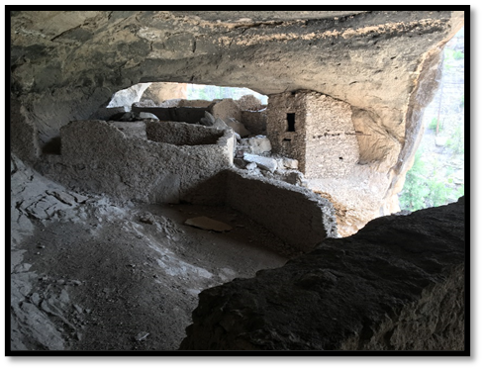The confluence of the West and Middle Fork River of the Gila is a region rich in history. This area contains almost 2,000 years of human occupation and cultural development which ranges from Archaic peoples to Mogollon built cliff dwellings. The headwaters of the Gila represent a colorful tapestry of indigenous and later American cultural stories. Today the archaeological and cultural treasures found in and around the headwaters of the Gila are preserved as the Gila Cliff Dwellings National Monument. It is managed and operated by the National Park Service to provide for the enjoyment of this and future generations. This power point presentation will take the audience on a cultural journey through 2,000 years of human occupation and cultural development of the Gila. In addition, this presentation will cover a small portion of the Spanish, Mexican, and American periods of southwest New Mexico and how it affected the people of the Gila. I end with the federal protection of both the Gila Cliff Dwellings and the surrounding Gila Wilderness.

Ranger guided hike up [Cliff Dweller Trail](https://www.alltrails.com/trail/us/new-mexico/gila-cliff-dwellings-trail) (1.1 miles/ 275’ elevation gain) to the dwellings.

**11:00 a.m. Lunch** (not provided – please plan accordingly as there are no food venders at the Monument)

**11:30 a.m. – 2:00 p.m. Hike** [**West Fork Trail #151**](https://www.alltrails.com/trail/us/new-mexico/west-fork-gila-river-trail) **&** [**Doc Campbell’s Post**](https://doccampbellspost.com/)

A moderate 5.7-mile out-and-back guided hike with less than 450’ elevation gain, the moderately challenging route follows and crosses the West Fork of the Gila River as it enters a canyon. Beginning from the parking lot of the Gila Cliff Dwellings, the trail crosses into the Gila Wilderness after the first ½ mile. The canyon narrows as the hike proceeds past cairn markers, through sections of pine forest and open floodplain, a settler’s gravesite, and culminating in a riparian area below an unprotected cliff dwelling. Participants should be generally fit and prepared for moderate inclines, multiple river crossings, and uneven terrain; dress in layers, bring at least 32 oz. of water, apply sunscreen, and have proper hiking footwear that can get wet.

On the return drive to Camp Thunderbird, we will stop at Doc Campbell’s for ice cream.

NOTES:__________________________________________________________________________________________________________________________________________________________________________________________________________________________________________________________________________________________________________________________________________________________________________________________________________________________________________________________________________________________________________________________________________________________________________________________________________________________________________________________________________________________________________________________________________________________________________________________________________________________________________________________________________________________________________________________________________________________________________________________________________________________________________________________________________________________________________________________________________________________________________________________________________________

**Call for Submissions**

*Looking to the Mountain: Sacred Lands, Healing Cultures*

*Gila Centennial Anniversary in Words and Pictures*

This edited Gila Centennial Anniversary Collection of poetry and photographs invites submissions of original work celebrating the ancestral homelands of the Gila Wilderness and the sacred union on nature and culture across time and space. Please submit up to Five Photographs (Color or Black & White), Art Imagery, Essays, Reflections (500 words or less) and/or Five Poems of any length for our review.

Our submission period opens August 15, 2024 and closes on January 15, 2025. Our editorial team will select work for this edited anniversary volume, and notify writers and artists of our decisions by mid-December. We accept simultaneous submissions, but ask that you kindly withdraw your submission. We do not consider previously published work.

Queries and Submission via email to Senior Editor:

Dr. Michelle Hall Kells ǀ Professor of Rhetoric, Writing, & EcoPoetics

University of New Mexico ǀ Department of Chicana and Chicano Studies

[mkells@unm.edu](mailto:mkells@unm.edu)