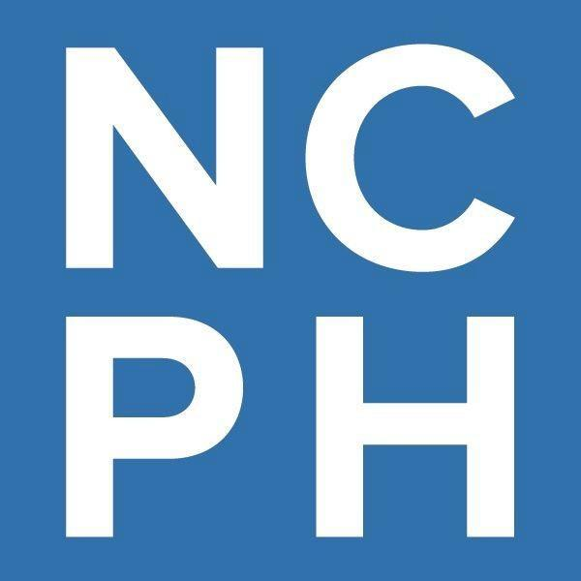

Accessibility, Disability, and Public History  
Call for Working Group Participants

The National Council on Public History (NCPH) values accessibility for people with disabilities. We have improved the accessibility of NCPH itself. We have also supported several projects that feature disability history and [disability justice](https://disabilityphilanthropy.org/resource/what-is-disability-justice/). But NCPH wants to enhance and improve its existing commitment to accessibility. We want to develop a plan we can follow to become a more accessible organization. We hope it can serve as a model for other organizations. To accomplish this, we will form a new working group. This working group will be a group of people who will meet online only to discuss accessibility and how to improve it at NCPH. This goal is supported by a grant from the [American Council of Learned Societies](https://www.acls.org/news/acls-awards-microgrants-to-support-academic-society-led-initiatives-to-foster-more-equitable-and-inclusive-engagement-with-early-career-scholars/). You are invited to participate in this project.

# What has NCPH done to support accessibility for people with disabilities and disability history?

Here are some of the ways NCPH has supported accessibility, disability, and public history:

* E[ncouraging participants at NCPH conferences and NCPH staff and volunteers to practice accessibility](https://ncph.org/about/governance-committees/ncph-accessibility-guidelines/).
* Nurturing interest in accessibility and inclusion issues within the organization and among its membership. NCPH’s [IDEA Committee](https://ncph.org/about/governance-committees/board-of-directors-and-committees/) (Inclusion, Diversity, Equity, and Accessibility) has adopted an intersectional approach in its work (or, an approach that considers multiple components of a person’s identity, such as race, class, gender, and ability).
* Cultivating accessibility in publications. For example, NCPH’s blog [has developed a disability language guide](https://ncph.org/wp-content/uploads/2023/12/Dis-Lang-Guide-NCPH-2022-Rev2023.pdf).
* Hosting an accessibility and public history working group for the 2016 annual meeting. [More information can be found here](https://ncph.org/phc/ncph-working-groups/making-public-history-accessible-2016-working-group/).
* Developing free workshops and webinars related to accessibility. In 2024, we offered a free workshop about the language of disability. In 2025, we will offer a workshop on conference accessibility for organizers and presenters.
* Working with the National Park Service and editor Kathleen Brian on a publication called *Introduction to Place-Based Disability History* (2025). This will help guide communication about place-based disability history and center disability as an essential focus of public history work.

# What are NCPH working groups?

# 

# NCPH working groups are groups of people who meet online or in-person to discuss a problem or issue in the field of public history. Most NCPH working groups are led by two-five leaders (called facilitators) and include up to fifteen other members (called discussants). They work together over several months or more. They propose solutions to or provide research or information about issues or problems. Working groups have covered a variety of topics. They have ranged from how to communicate about the history of the World War II home front to sharing information about how to teach public history. Working groups produce a product or deliverable of some kind. They might be blog posts, written recommendations to NCPH, written recommendations for public historians, or something else.

# What will this new working group do?

NCPH uses working groups to discuss issues together. We want to create a dedicated working group of public historians who will meet online throughout 2025. This working group will:

* Identify the obstacles for public historians with disabilities to take part fully in NCPH programs and that of other history membership organizations;
* Help NCPH develop a plan to discuss those obstacles;
* Encourage public historians to share and learn from disability history in their work;
* Share conclusions in the form of a written report, blog posts, or in another accessible way.

# What will this NCPH working group be like?

# This NCPH working group will be led by up to five facilitators who set the meeting agendas and lead the conversation. They also maintain communication with NCPH staff and others. Facilitators often have some experience working or volunteering on projects in the history profession. This NCPH working group will also include up to fifteen discussants. Discussants are people in the working group who share their perspectives (sometimes called case statements) with each other and the facilitators before meetings. In the case of this working group, we are looking for facilitators and discussants who have an interest in or expense working or volunteering on issues related to accessibility in public history.

# Will this working group be different from other NCPH working groups?

Yes. This working group will meet online only from January-December 2025. There will be no in-person meetings.

# What will this working group do?

This working group will:

* Come up with ideas for how NCPH can be more accessible to public historians with disabilities;
* Update the public history community on its progress; and
* Create a tangible end product or deliverable.

Working group facilitators, discussants, and NCPH will come up with an end product or deliverable. NCPH hopes the end product could take the form of:

* A white paper, blog posts, or other shareable material that will propose how to make NCPH more inclusive for public historians with disabilities.

This deliverable might be:

* a needs assessment (or a report on what NCPH does well regarding accessibility and what it could do better); an update to the [Conference Accessibility Guidelines developed in 2019](https://ncph.org/about/governance-committees/ncph-accessibility-guidelines/); additional guidelines for our work outside of the annual meeting; suggestions for how NCPH can take accessibility into consideration when it plans for the future or comes up with committee tasks and assignments; or something else.

This work might also include:

* Gathering accessibility practices from other scholarly organizations, internship programs, or graduate educators to ensure maximum accessibility for disabled constituents.
* Designing a way for NCPH to evaluate its accessibility and inclusion practices for historians with disabilities regularly and suggest and make changes as needed.

# Will this working group receive funding?

Yes. NCPH received a small grant from the [Intention Foundry Learned Society Extended Engagement Microgrant](https://www.acls.org/news/acls-awards-microgrants-to-support-academic-society-led-initiatives-to-foster-more-equitable-and-inclusive-engagement-with-early-career-scholars/) from the American Council of Learned Societies. Each of the five (5) facilitators will receive an honorarium of $500. The working group will have an additional $900 to spend on guest presenters and accommodations such as ASL interpretation or CART captioning. NCPH will provide additional funding if needed and available.

# How can I be involved?

We’re looking for up to five NCPH members to serve as **facilitators** of the working group. Facilitators will lead the group and will keep NCPH and the public updated on the work of the group. We expect this role will take 2-3 hours per month from January 2025-December 2025. Each facilitator will receive a $500 stipend for their work.

We’re also looking for approximately eight **discussants**. Ideally, at least one discussant will be a graduate student and at least one discussant will be in the early stages of their career outside academia. Discussants do not receive stipends.

# Other Details

We aim to recruit people with both visible and invisible disabilities and allies. Race, gender, ethnicity, and other parts of a person’s identity impact their experience with disability, so we will keep that in mind when we select working group members.

Neither facilitators nor discussants need to be members of NCPH. All public historians are welcome to send applications. Applications will be reviewed by NCPH staff and members of the NCPH Inclusion, Diversity, Equity, and Accessibility Committee (IDEA).

# 

# How to Apply

If you are interested in facilitating (leading) the working group with a small group of other people, please complete the form [here](https://ncph.org/accessibility-working-group-application/) or email [ncph@iu.edu](mailto:ncph@iu.edu) by November 15, 2024, with the following information:

* Name, Affiliation, Email Address, and Career Stage (student, early career, mid career, established public historian, retired public historian, or adjacent to public history participant).
* A commitment to give 2-3 hours a month to the work of this group, and to hold meetings periodically on a timeline mutually agreed upon between the group's participants and NCPH.
* A brief description of what experience you have with facilitating work between a group of approximately fifteen people. How was that experience? What were the outcomes?
* A one paragraph description of your own experiences with disability or accessibility in your life and work. Please share only what you're comfortable with. This information may help us ensure that the group represents the varied experiences of disability and access needs. This information will not be shared beyond the selection committee for the working group without further permission from you.
* Brief list of what you would want to discuss or do if you were involved in the working group. What questions would you like the group to answer? What challenges do disabled public historians face that you consider most urgent? If there's an aspect of this work you are most interested in and it didn't come up above, please mention it here!
* Brief biographical statement and/or CV.

If you are interested in joining the group as a discussant, please complete the form [here](https://ncph.org/accessibility-working-group-application/) or email [ncph@iu.edu](mailto:ncph@iu.edu) by December 1, 2024, with the following information:

* Name, Affiliation, Email Address, and Career Stage (student, early career, mid career, established public historian, retired public historian, or adjacent to public history participant).
* A one paragraph description of your own experiences with disability and accessibility in your life and/or work. Please share only what you're comfortable with. This information will help us ensure that the group is balanced in terms of the many varied experiences of disability and access needs. This information will not be shared beyond the selection committee for the working group without further permission from you.
* Brief list of what you would want to discuss or do if you were involved in the working group. What questions would you like the group to discuss? What challenges do disabled public historians face that you consider most urgent? If there's an aspect of this work you are most interested in and it didn't come up above, please mention it here!
* Brief biographical statement or CV.

# When will I hear from you?

Facilitators: We hope to choose facilitators by November 22, 2024.

Discussants: We hope to choose discussants by December 15, 2024.

Full working group: We hope to have the full working group assembled by January 20, 2025.

First meeting: We hope the group’s first meeting will take place in February 2025, with work continuing through the year. The work of the group (including the frequency and format of meetings) will be decided by the facilitators.

We hope the working group can share a progress report or draft of a product that can be shared widely by October 15, 2025.

Working group completion: December 31, 2025.

# What if I have questions about this opportunity?

If you have questions, please contact NCPH at [ncph@iu.edu](mailto:ncph@iu.edu).