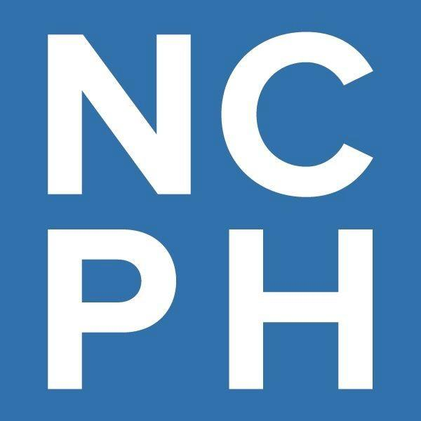

Accessibility, Disability, and Public History  
Call for Working Group Participants

Over the last seven years, the National Council on Public History (NCPH) has increasingly focused on improving our organizational accessibility and has engaged in projects that center disability history and disability justice. These efforts have largely been piecemeal as resources and time allowed, but with support from the [American Council of Learned Societies](https://www.acls.org/news/acls-awards-microgrants-to-support-academic-society-led-initiatives-to-foster-more-equitable-and-inclusive-engagement-with-early-career-scholars/) we now plan to develop a cohesive and comprehensive strategy for becoming a more accessible organization that we hope can serve as a model for other membership and professional organizations.

NCPH has been working toward improving accessibility and encouraging complex understandings of disability history and disability justice in the following ways:

* E[ncouraging accessible best practices at conferences](https://ncph.org/about/governance-committees/ncph-accessibility-guidelines/).
* Nurturing interest in accessibility and inclusion issues within the organization and among its membership. NCPH’s [IDEA Committee](https://ncph.org/about/governance-committees/board-of-directors-and-committees/) (Inclusion, Diversity, Equity, and Accessibility) has adopted an intersectional approach in its work.
* Cultivating accessibility in publications. NCPH’s blog [has developed a disability language guide](https://ncph.org/wp-content/uploads/2023/12/Dis-Lang-Guide-NCPH-2022-Rev2023.pdf).
* Hosting a working group for the 2016 annual meeting, the participants and case statements for which can be found at <https://ncph.org/phc/ncph-working-groups/making-public-history-accessible-2016-working-group/>.
* Developing free workshops and webinars related to accessibility; for example, a 2024 workshop about the language of disability and an upcoming workshop in early 2025 focused on conference accessibility for organizers and presenters.
* Working with the National Park Service and lead editor Kathleen Brien on the development of a forthcoming *Introduction to Place-Based Disability History* (2025), which will help guide interpretation of place-based disability history and center disability as an essential focus of public history work.

NCPH uses working groups to address issues that call for concentrated, collaborative work. To that end, we aim to assemble a dedicated working group which will consist of public historians who will meet online throughout 2025. This working group will identify the barriers that limit the participation of public historians with disabilities in the professional development and networking opportunities of NCPH and its peer membership organizations, help NCPH develop a cohesive strategy to address those barriers, and encourage public historians to use disability as a lens for interpretation and historical understanding in their own work. The group will share their conclusions in the form of a written report, white paper, blog posts, and/or other more transparent, engaging means.

# What is a typical NCPH working group, and how would this be different?

NCPH working groups are groups of up to five facilitators and up to fifteen discussants that usually form in October and work up through our annual meeting in the spring. They write and share case statements in advance of their in-person meeting at the conference. They are working to solve a specific problem, and from their work they create a tangible product (such as a best practices guide, a white paper, or a series of blog posts).

This working group will be entirely virtual and will meet from January through December 2025 instead of the usual schedule of our other annual meeting working groups. The group is charged with creating a framework for NCPH to become more accessible to public historians with visible and invisible disabilities. We would expect the working group to periodically update the public history community on its progress and to create a tangible end product.

The end product will be determined by the group’s facilitators in consultation with discussants and NCPH and should attempt to address our desired outcomes:

* Development of a white paper, blog posts, or other shareable material that will set a path forward for making NCPH more inclusive for public historians with disabilities (i.e. a needs assessment, an update to the [Conference Accessibility Guidelines developed in 2019](https://ncph.org/about/governance-committees/ncph-accessibility-guidelines/), or development of a second set of guidelines for our work outside of the annual meeting).
* Strategies for inclusion of accessibility needs and considerations throughout the organization from long range planning work to committee tasks and assignments.
* Collecting/Assembling/Analyzing models for other scholarly organizations, internship programs, and/or graduate educators to follow to ensure maximum accessibility for disabled constituents.
* Designing a way for NCPH to continually reassess its accessibility and inclusion practices for historians with disabilities and suggest and make changes as needed.

This working group comes with a modest amount of financial support through NCPH’s receipt of an [Intention Foundry Learned Society Extended Engagement Microgrant](https://www.acls.org/news/acls-awards-microgrants-to-support-academic-society-led-initiatives-to-foster-more-equitable-and-inclusive-engagement-with-early-career-scholars/) from the American Council of Learned Societies. Each of the five(5) facilitators will receive an honorarium of $500. The facilitation group will have a budget of $900 which in the grant we suggested as dividing in the following way: $400 for honorariums for accessibility experts to present or work with the group and $500 to provide CART, ASL, or other services for meeting facilitation NCPH will provide twenty (20) hours of staff time to support the group and access to NCPH’s Zoom platform to host meetings. This budget does not preclude the possibility of NCPH dedicating additional funds to the group as they become available.

# What is NCPH looking for?

We’re looking for up to five NCPH members to serve as **facilitators** of the working group; the facilitators will lead the group and will keep NCPH and the public updated on the work of the group. We anticipate this role will take 2-3 hours per month from January 2025-December 2025, and each facilitator will receive a $500 stipend for their work.

We’re also looking for approximately eight **discussants** representing a wide variety of public historians. Ideally, at least one discussant will be a graduate student and at least one discussant will be in the early stages of their career outside academia. We aim to recruit with consideration for intersectionality and both visible and invisible disabilities, understanding that race, gender, ethnicity, and other markers of identity impact a person’s experience of their disability.

Neither facilitators nor discussants need to be members of NCPH, and all public historians are welcome to submit. Applications will be reviewed by an ad hoc group including NCPH staff and members of the NCPH IDEA Committee.

If you are interested in facilitating the working group, please complete the form [here](https://ncph.org/accessibility-working-group-application/) or email [ncph@iu.edu](mailto:ncph@iu.edu) by November 15, 2024, with the following information:

* Name, Affiliation, Email Address, and Career Stage (student, early career, mid career, established public historian, retired public historian, or adjacent to public history participant.
* A commitment to give 2-3 hours a month to the work of this group, and to hold meetings periodically on a timeline mutually agreed upon between the group's participants and NCPH.
* A brief description of what experience you have with facilitating work between a group of approximately fifteen people. How was that experience? What were the outcomes?
* A one paragraph description of your own experiences with disability and/or accessibility in your life and work. Please share only what you're comfortable with, but it will help us ensure that the group is balanced in terms of the many varied experiences of disability and access needs. This information will not be shared beyond the selection committee for the working group without further permission from you.
* Brief outline of your priorities would be if you were involved in the working group. What questions would you like the group to address? What challenges do disabled public historians face that you consider most urgent? If there's an aspect of this work you are most interested in and it didn't come up above, please mention it here!
* Brief biographical statement and/or CV.

If you are interested in joining the group as a discussant, please complete the form [here](https://ncph.org/accessibility-working-group-application/) or email [ncph@iu.edu](mailto:ncph@iu.edu) by December 1, 2024, with the following information:

* Name, Affiliation, Email Address, and Career Stage (student, early career, mid career, established public historian, retired public historian, or adjacent to public history participant.
* A one paragraph description of your own experiences with disability and accessibility in your life and/or work. Please share only what you're comfortable with, but it will help us ensure that the group is balanced in terms of the many varied experiences of disability and access needs. This information will not be shared beyond the selection committee for the working group without further permission from you.
* Brief outline of your priorities would be if you were involved in the working group. What questions would you like the group to address? What challenges do disabled public historians face that you consider most urgent? If there's an aspect of this work you are most interested in and it didn't come up above, please mention it here!
* Brief biographical statement or CV.

**What is the timeline?**

We hope to select facilitators by November 22, 2024, discussants selected by December 15, 2024, and would like to have the full working group assembled by January 20, 2025. We hope and plan for the group’s first meeting to take place in the month of February, with work continuing through the year.

The work of the group (including the frequency and format of meetings) will be determined by the facilitators. The suggested date for a progress report or draft of a product that can be shared more widely is October 15, 2025, with completion of the group by December 31, 2025.