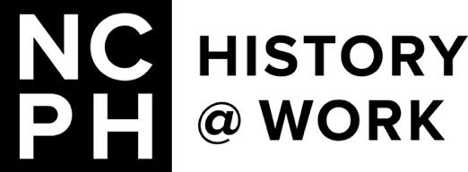

Call for History@Work Pitches

on Documenting Historical Change

In 2018, History@Work partnered with The Public Historian to publish a series of posts based on the concept of “rapid response” to community crises. The posts featured reflections on collecting, archiving, and documenting around community traumas ranging from natural disasters, to mass shootings, to protests against Confederate memorialization.

In 2020, we published a series in honor of Archives Month featuring the variety of archival responses to the COVID-19 pandemic and the related crises it helped to illuminate.

Six years later, many public historians find themselves facing a different set of pressures, including governmental censorship, institutional dismantlement, and concerns about surveillance and safety for protesters. We are living in a moment in which years of work undertaken at federal and state institutions may be threatened with dismantlement or suppression, and so the work of documentation and preservation feels all the more urgent.

Given these interlocking pressures, History@Work is interested in pitches related to documenting and preserving public history information and evidence of institutional disruption. For example, the Data Rescue Project has worked to archive National Park Signs at risk of removal. Colleagues facing funding cuts and departmental restructuring in response to (or anticipation of) state mandates have shared stories of saving project archives on external hard drives and printing paper copies of reports and files for future access. The Organization of American Historians has initiated an oral history project to document the experiences of federal workers impacted by administrative policies and actions. We have also seen the impact of community commitments to historical interpretation.

We are aware that public historians have legitimate concerns about consequences that they might face at their jobs if this work is made public. We are also aware of the need to protect the privacy of protesters and activists whose opposition to governmental policies or actions may put them in danger of retaliation. Acknowledging these realities, and knowing that it is impossible for History@Work to guarantee anonymity for authors, we maintain a policy of not publishing anonymous posts.

For that reason, we encourage posts from retired and former staffers and other collaborators and partners who feel that they are in a less precarious position to share about this important work. We are hopeful that providing perspectives and guidance through History@Work can help members of the public history community craft their own responses to this challenging historical environment.

